1. College Name and Logo should be displayed in the below space and in pdf

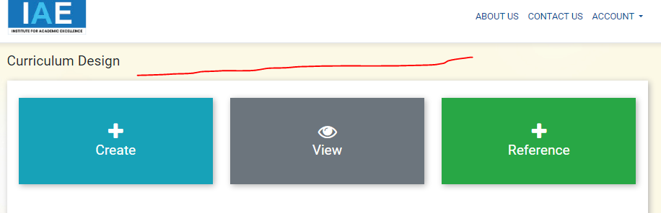

1. Remove Pop-up message 30min - done

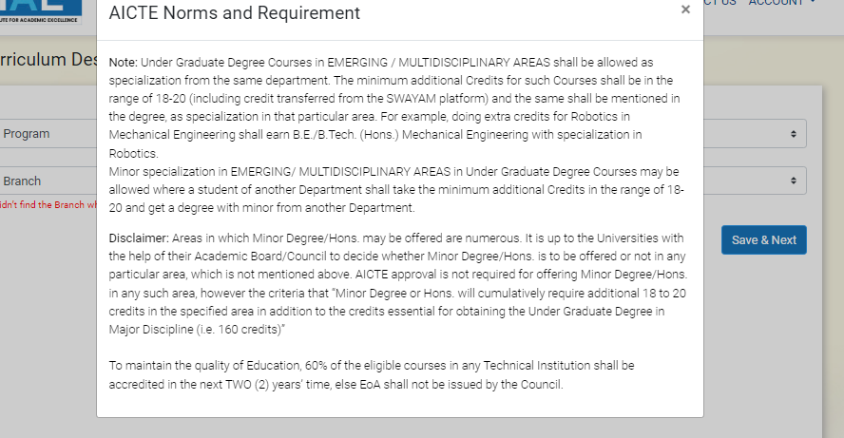

1. Change Program to ‘Choose Program Level’, Course to ‘Choose Program’ and Branch to ‘Choose Branch’. 30min - done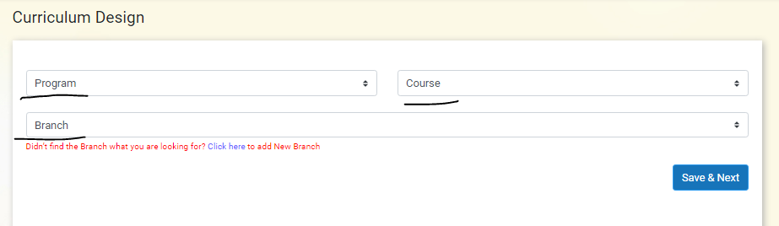
2. Correct the spelling of category 30min-done

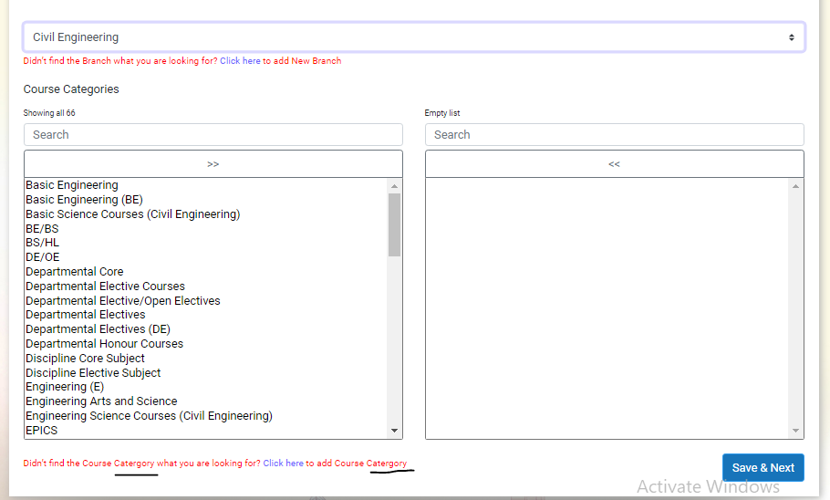

1. Provide check boxes to subjects to select whether to give credits for lecture, tutorial and practical hours or not. (important and high priority) 30hrs - done
2. Categories should have numbering. 2hrs - done

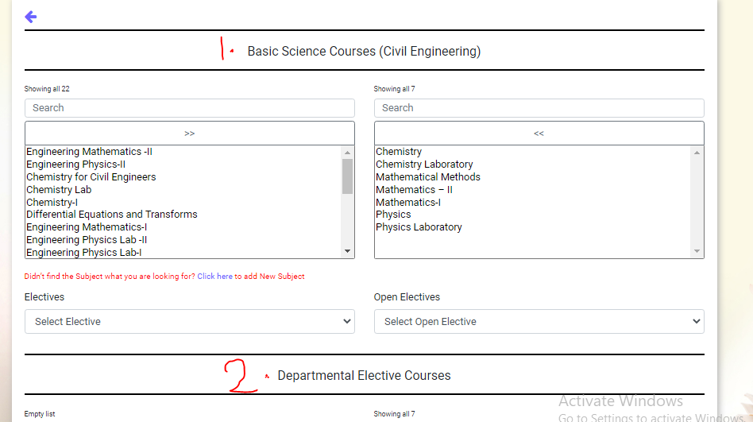

1. Electives and open electives dropdowns should be as discussed.
2. When we add or remove any subject after creating the course the values of the other subject below the newly added subject are getting shifted up, fix this issue.

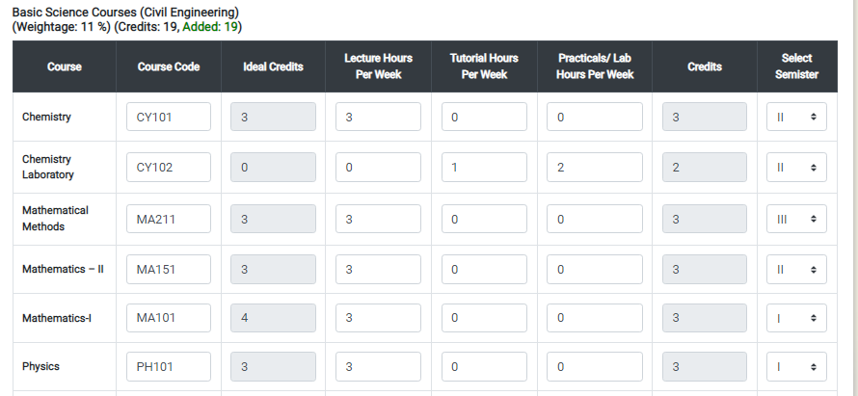

1. Add Fourth section in dashboard which will have instructions/guidelines and displays documents/pdf’s, (super admin will upload the pdfs with a title)
2. Change subject to ‘Course Name ’ 30min - done

Sample: Didn’t find the Course Name you are looking for? Click here to add the Course Name

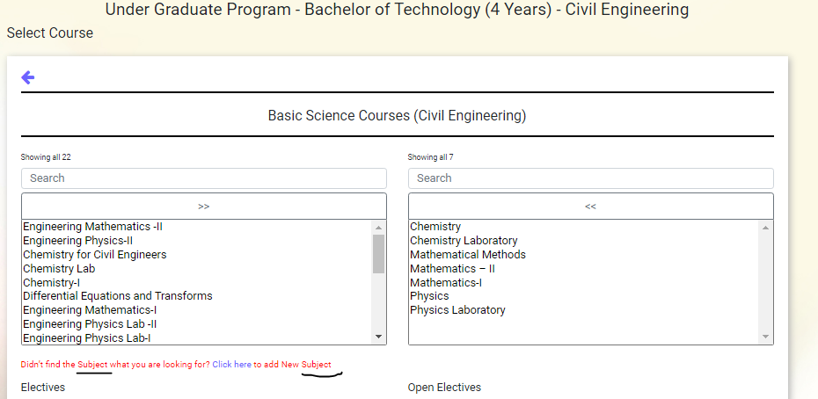

1. Under View section change the Program Name to ‘Program Level’ and Course Name to ‘Program Name’ 30min - done

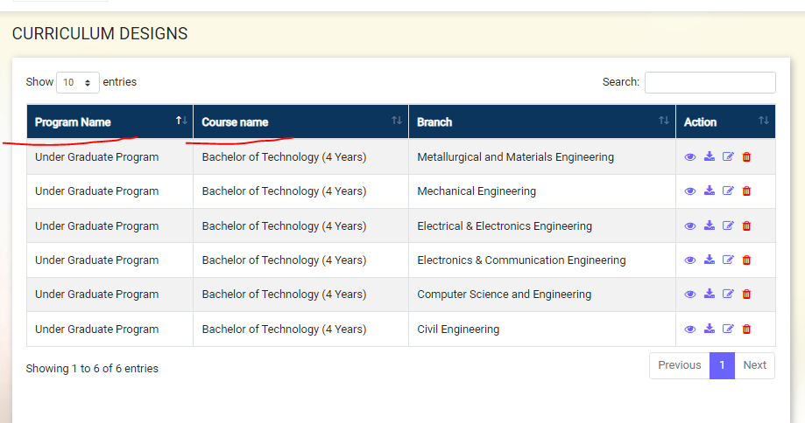

1. Name in the pdf download by reference is showing the logged in institution name, please change as discussed.

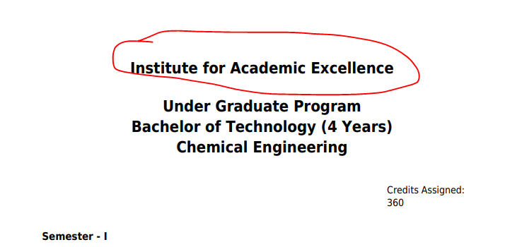

1. PDF page size should be adjusted to A4, and try to make sure the tables not split into multiple pages.